Memo

TO: | Non-Profit and Government Agencies
FROM: | Cindy Waterhouse, Vanpool Manager Intercity Transit
SUBJECT: | Application for Surplus Van Grant Program
DATE: | 09/25/2020

Intercity Transit is pleased to announce our Surplus Van Grant Program for 2020. This year, the program will grant a number of vans to help community agencies enhance transportation services to Thurston County residents. The vans, which are earmarked for retirement this year, will be awarded to eligible non-profit and government agencies serving the Thurston County Public Transportation Benefit Area (PTBA).

If you have questions about the application process, selection criteria, van maintenance, mileage, upkeep, or the history of the Van Grant program just give us a call.

The application is attached to this memo along with an information packet that provides specific details on the application process. Applications are also available at www.intercitytransit.com or by calling (360) 786-8800.

Completed applications can be emailed to vans@intercitytransit.com, mailed to Intercity Transit Surplus Van Grant Attn: Riley White, PO Box 659, Olympia, WA 98507, or placed in our Vanpool Payment Dropbox located at 526 Pattison Street SE in Olympia. Applications are due October 23, 2020.

If you have questions about the application process, selection criteria, van maintenance, mileage, upkeep, or the history of the Van Grant program just give us a call at (360) 786-8800 or email us at vans@intercitytransit.com.

Intercity Transit
Rules/Requirements and Selection Criteria for Surplus Vans

Background
The Intercity Transit Authority Board approved Resolution 07-03 on September 3, 2003, authorizing the Surplus Van Grant program. This annual program grants retired passenger vans to eligible non-profit organizations and community agencies to enhance transportation service provided within Thurston County’s Public Transportation Benefit Area (PTBA). This packet contains the application, rules, requirements, and selection criteria for the program.

Eligibility
All non-profit organizations and community agencies (with 501(c)(3) status) and agencies that serve residents of the Thurston County PTBA are eligible. The PTBA serves the urban growth areas of Olympia, Lacey, Tumwater, and Yelm.

Other Rules and Requirements
- Vans must be used for a transportation-related purpose for residents who live within Intercity Transit’s PTBA.
- Organizations must be located within Intercity Transit’s PTBA.
- Only one van will be awarded per agency/organization per year.
- Application must clearly designate the primary applicant, who will be named as buyer on vehicle title, if selected as a recipient.

- Transportation must originate within the PTBA and remain within a 150-mile radius of the Intercity Transit’s PTBA.
- Applicants must certify they have the financial ability and management capacity to insure granted vehicles, if selected as a recipient.
- Applicants must certify they have the financial and management capacity to maintain vehicles in good working condition.
- Applicants must provide a copy of their 501(c)(3) non-profit certification, if applicable.
- Successful applicants will be required to sign an agreement relating to the exchange of vehicles for passenger transportation-related services. A sample agreement is included in this packet.
- Reporting Requirements: Grantees must track ridership, hours, miles of service, and provide a quarterly report to Intercity Transit for one calendar year.
- Restrictions: Trips to or from religious worship, devotion or instruction may not be counted in meeting the “trips provided” selection criteria. This restriction does not affect the use of the van after an award has been made.
- If vans are not used for transportation of riders as stated in application materials, grantees will return the van to Intercity Transit or they may be required to pay Intercity Transit the fair market value of vehicle.
- Grantees shall provide transportation only to their clients, members, guests, or other similar users with vans supplied under this program. They shall not provide transportation to the general public.
- Grantees shall not use the vehicle for assisting a campaign for election or for the promotion of or opposition to any ballot proposition.

Application Schedule
October 23, 2020 | Deadline for submitting applications
November 18, 2020 | Announcement of van grant awards

Application Submittal
A copy of the application is attached. The application is also available on Intercity Transit’s website: www.intercitytransit.com This application packet is available in other formats/languages by request.

Applications must be received by Friday, October 23, 2020. Applications must contain the appropriate certification signatures, proof of insurability, and a copy of organizations 501(c)(3) non-profit certification, if applicable. Electronic signature is acceptable.

Completed applications can be emailed to vans@intercitytransit.com, mailed to Intercity Transit Surplus Van Grant Attn: Riley White, PO Box 659, Olympia, WA 98507, or placed in our Vanpool Payment Dropbox located at 526 Pattison Street SE in Olympia.

Selection Criteria Summary
The review process is competitive and will use the criteria identified below. In addition, geographic equity, diversity in population groups served, and previous grant award may be used as balancing factors in making final selections.

CRITERIA: | WEIGHT:
1. Demonstrated Community Benefit | 50%
2. Total Number of Trips Provided | 30%
3. Clarity and Quality of Application | 5%
4. Coordination of Services | 5%
5. Ability of Organization to Maintain Vehicle | 10%

Selection Criteria: Successful applications will address all five criteria

Demonstrated Community Benefit
Clearly explain the scope and nature of your agency transportation needs and provide data to back up that need. Explain how you would serve an unmet public transportation need in Intercity Transit’s PTBA. Identify the transportation services you currently use, what other options are available to your agency or organization and how your program will coordinate with other programs to get maximum use.

Total Number of Trips Provided
Clearly define and document the number of trips to be provided annually. Give the best estimate you can as to where the trips would go. Trips to or from religious worship, devotion or instruction may not be counted in meeting the selection criteria. This restriction does not affect the use of the van once an award has been made.

Clarity and Quality of Application
Applications will be rated on content, clarity, presentation, and quality of the proposal based on legibility, completeness, inclusion of data and clear description of transportation needs.

Coordination of Service
Describe how your current and proposed service coordinates with other transportation services in the area to ensure broad community benefit. Describe why existing Intercity Transit services do not meet your needs.

Ability to Maintain Service
Describe how the proposed transportation program will be maintained and funded and how the agency or organization will manage the program.

SAMPLE AGREEMENT

AGREEMENT RELATING TO THE EXCHANGE OF VEHICLE FOR TRANSIT RELATED SERVICES

THIS AGREEMENT between the Thurston County Public Transportation Benefit Area, (hereinafter called “Intercity Transit”), and

, (hereinafter referred to as the “Vehicle Recipient”) as follows:

In consideration of the mutual promises of the parties, it is hereby agreed as follows:

- Intercity Transit shall provide to the Vehicle Recipient the following described vehicle:

Make: Year: Model: VIN:
- The Vehicle Recipient shall provide the following services in consideration for the vehicle: enhanced transportation services for residents who live within Intercity Transit’s PTBA as described in Section 2, Description of Proposed Vehicles Use, in the application. Use of the vehicle for other purposes is prohibited. If the Vehicle Recipient does not use the vehicle for the above transportation service for a period of one (1) year, the Vehicle Recipient shall forfeit the vehicle within thirty days and the vehicle shall be returned to Intercity Transit. Intercity Transit may use any remedy provided by law for breach of this agreement.

- Intercity Transit is giving the Vehicle Recipient the vehicle AS IS, WHERE IS, and WITH ALL FAULTS and WITHOUT RECOURSE regarding the condition of the vehicle. Intercity Transit makes NO EXPRESSED or IMPLIED WARRANTIES of MERCHANTABILITY; NO EXPRESS or IMPLIED WARRANTIES of FITNESS; and no EXPRESS or IMPLIED WARRANTIES or GUARANTEES of any kind regarding the vehicle.

- The parties to this Agreement agree that Intercity Transit shall have no liabilities of any sort arising from or related to the vehicle or vehicles covered by this Agreement. The Vehicle Recipient(s) and any successor shall defend, indemnify and hold harmless Intercity Transit, its officers, agents and employees from any claims or suits

at law or equity, costs and/or demands of any sort, including reasonable attorney’s fees, arising out of or related to this Agreement, the vehicle or vehicles covered by this Agreement, or any use by any person of such vehicles.

- If the Vehicle Recipient sells, donates or transfers any vehicle or vehicles covered by this Agreement, the Vehicle Recipient shall require the transferee to execute a binding agreement to defend, indemnify and hold Intercity Transit and its officers, agents and employees harmless as set out in the above provision.

- The Vehicle Recipient shall be responsible for all licensing, permits and insurance of the vehicle. Proof of insurance shall be provided to Intercity Transit as a condition of delivery of the vehicle. Vehicle Recipient shall promptly carry out all steps necessary to transfer vehicle title to it from Intercity Transit.

- The Vehicle Recipient shall provide to Intercity Transit a report, quarterly for one year, containing vehicle odometer readings, number of passengers carried, and description of vehicle use. Reporting schedule is below:

Report due date: | Period covered:
April 30, 2021 | January 1, 2021 – March 31, 2021
July 31, 2021 | April 1, 2021 – June 29, 2021
October 31, 2021 | July 1, 2021– September 28, 2021
January 31, 2021 | October 1, 2021 – December 31, 2021

Information shall be submitted to Intercity Transit, Attention: Riley White PO Box 659, Olympia, WA 98507-0659, or emailed to vans@intercitytransit.com.

- The Vehicle Recipient will assure they only provide transportation services to their clients, members, guests, or other similar users, with vans supplied by this program. Grantee will not use the vehicle for assisting a campaign for election, for the promotion of or opposition to any ballot proposition, or to the general public.

- If van is not used for transportation of riders as stated in application materials, grantees will return van to Intercity Transit or may be required to pay the fair market value of the vehicle.

- The Vehicle Recipient will ensure that the trips originate within Intercity Transit’s PTBA and remain within a 150-mile radius of the PTBA.

DATED:

THURSTON COUNTY
PUBLIC TRANSPORTATION BENEFIT AREA

By:

Printed name:

Title:

ATTEST:

Vehicle Recipient

By:

Printed name:

Title:

Witness

Printed name:

.

INTERCITY TRANSIT

Application for Surplus Van Section 1: General Information
1. | Name of Primary Applicant Agency/ Organization:
2. | Mailing Address:
3. | Contact Person/Telephone:
4. | Email Address:
5. | Partner Agency/ Organization:

  - Type of Applicant(s) (check all that apply):

 | Church |  | Public Agency |  | School/Daycare
 | Community Service Organization |  | Senior Center/ Convalescent Center |  | Other, please specify

Section 2: Description of Proposed Vehicle Use
    - Describe the community transportation problem you are proposing to solve with this vehicle and the benefit you want to achieve. Describe the type of service you will provide, purpose of the transportation, extent of vehicle use and any other information you want us to know. (Attach an additional sheet, if needed.)
Description of community transportation need and benefit to be achieved:

    - How many passenger trips do you expect to provide over the course of the next year? For the purposes of this application, a passenger trip is defined as a round trip for one person, i.e. to/from their destination. Please show how you arrived at your estimate and describe the basis of your projection. Trips to or from religious worship, devotion or instruction may not be counted in meeting the selection criteria. This restriction does not affect the use of the van once an award has been made.

The hypothetical example below illustrates the type of information we are looking for in this question. In this example, the van would be utilized to support several programs within one organization.

Samples
Our group expects to utilize the van to provide 1938 passenger trips over the next year based on the following:
      - 4 people to food bank each Monday = 4 people x 52 Mondays = 208 Basis: average number of people carried last year in old van
      - 5 people to place of employment each workday = 5 people x 250 workdays = 1250 Basis: current number of developmentally disabled clients lacking daily transportation to work
      - 20 seniors on field trip one Saturday per month = 20 people x 12 field trips = 240 Basis: planned new program if a vehicle is available
      - 48 low-income children to a week-long summer camp in June = 48 people x 5 days
= 240
Basis: attendance at last year’s camp
Description of annual passenger trips:

    - Describe the profile of the passengers you anticipate serving with this vehicle. Profiles include, but are not limited to, persons with disabilities, senior citizens, persons with low income, at risk youth, and the general public. Of the passengers you plan to serve, what percentage reside in Thurston County?

Profile of passengers served:

    - Describe your service area within Thurston County.
Description of agency or organization service area:

    - Describe how your agency or organization coordinates transportation efforts with other community programs?
Coordinating transportation with other community programs:

    - What method of transportation does your program currently use to meet your agency or organization transportation needs?
Coordinating transportation with transportation providers:

    - a) To what extent do existing bus and Dial-a-Lift (DAL) services meet your agency or organization’s transportation needs?
How bus and DAL services meet organization needs:

b) Do Intercity Transit services meet the transportation needs of your agency or organization? If not, why?
Why current IT service does not meet agency or organization needs:

    - a) Will the vehicle be used to expand service or replace existing service?

Expand Service □ Replace Existing □ Both □

- If the vehicle will be used to expand service, estimate the number of new trips that will be provided and/or explain how the vehicle will be used to expand service. (Attach additional sheets if necessary).
Explanation of how service will expand, if applicable:

- If the vehicle will replace existing service, please state the age and mileage of your current vehicle(s) and estimate the number of trips that will be provided with the vehicle.
Current service that will be replaced, if applicable:

    - Is this application in coordination with any other agencies? Yes No

- If yes, list the name of the primary applicant who will be named as buyer on vehicle title if selected as a vehicle recipient

Name of primary applicant (named as buyer on vehicle title):

- Briefly explain how the use of the vehicle will be divided among the agencies/ organizations involved. (All participating agencies or organizations are required to sign the certification and should also be identified on Page 1 of this application).
Description of agency or organization service area:

    - Describe how the proposed transportation program will be maintained and funded and how the organization will manage the program and the vehicle.
Plan for maintaining and funding the program and vehicle to include insurance:

Section 3: Certification

I certify that, to the best of my knowledge, the information in this application is true and accurate and that this agency/organization has the necessary financial and managerial capability to adequately operate, maintain and insure the vehicle for which this application is being made.

Signature of Lead Agency/Organization
Board Chair/Executive Officer: Printed Name/Title: Date:
Email Address:_____________________________________________________________

Signature of Partner Agency/Organization
Board Chair/Executive Officer: Printed Name/Title: Date:
Email Address:____________________________________________________________
Signature of Partner Agency/Organization
Board Chair/Executive Officer: Printed Name/Title: Date:
Email Address:____________________________________________________________

Figure 2.1 – Intercity Transit System Map including PTBA Boundary
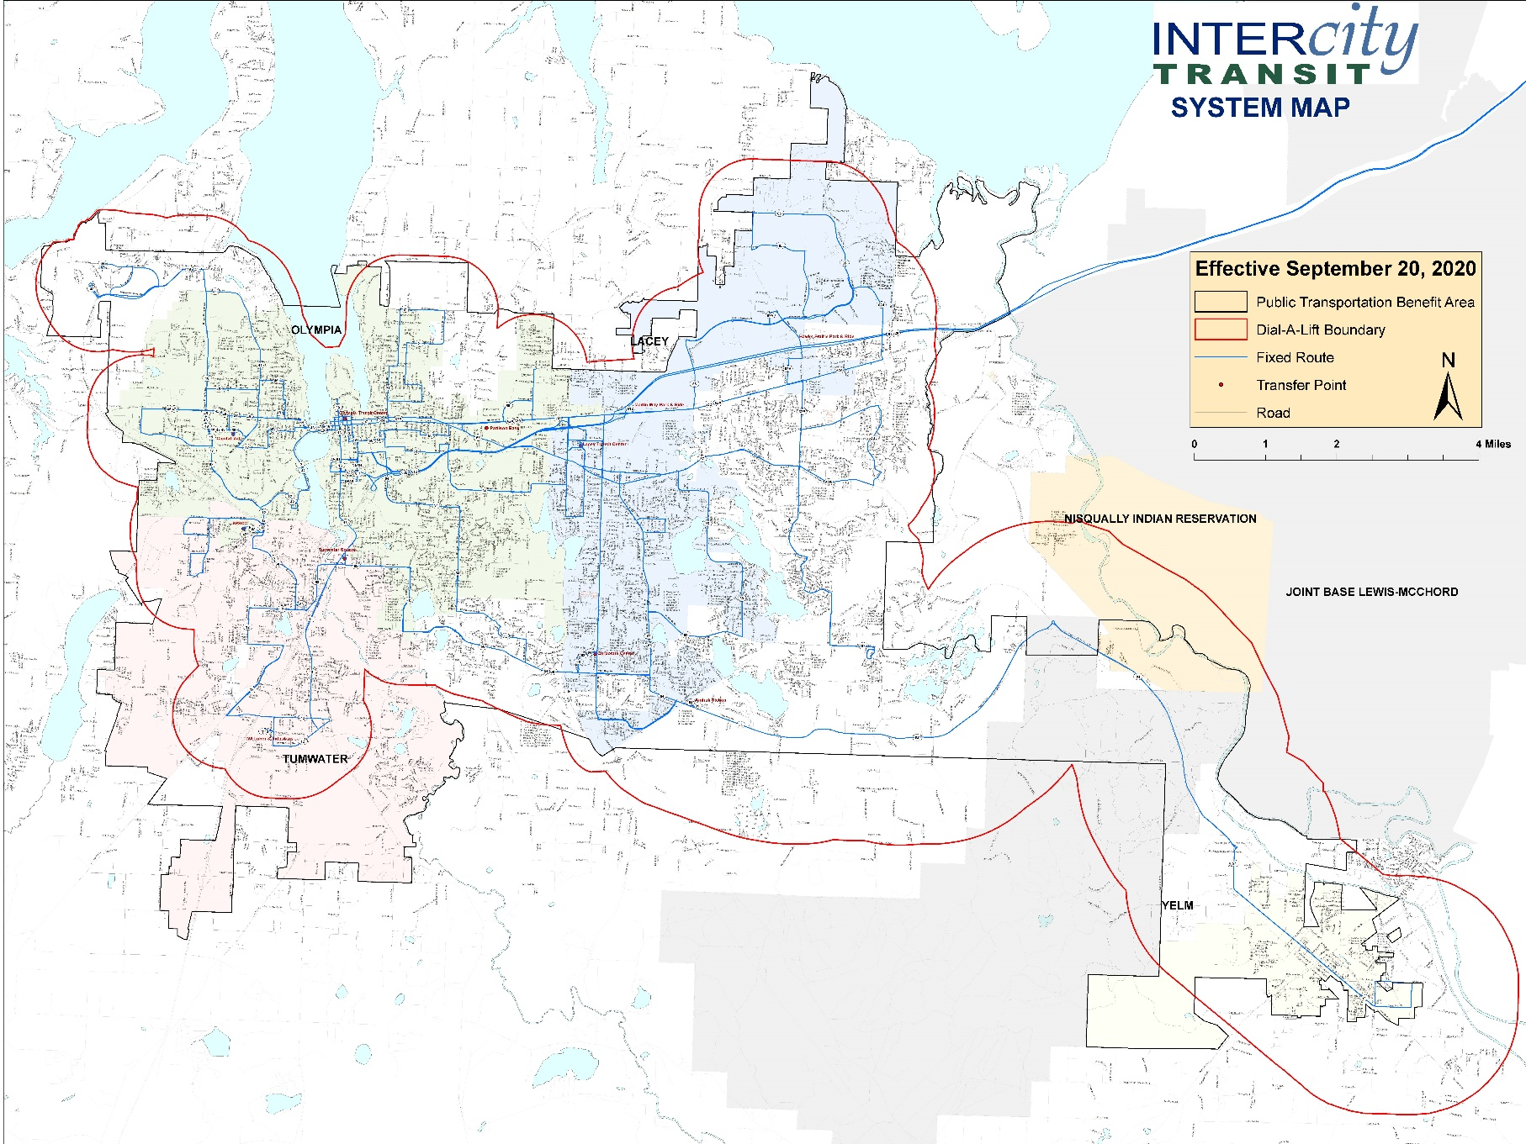

Application Submission Check List

Include the completed application

- Identify the primary applicant

- Get all required signatures

- Include a copy of each agency 501(c)(3) Non-Profit Certification (if applicable)

- Include Proof of Insurance for Agency

- Mail, email, or Deliver by October 23, 2020

Submit packet using one of the following methods:

Email to vans@intercitytransit.com
Mail to Intercity Transit Surplus Van Grant Attn: Riley White, PO Box 659, Olympia, WA 98507
Drop off location: Vanpool Payment Dropbox located at 526 Pattison Street SE in Olympia.

